**Redesign the app:**

[How learning a sign language made me a better designer | by Chiara Angori | Doctolib | Medium](https://medium.com/doctolib/how-learning-a-sign-language-made-me-a-better-designer-dc42e564bfe1)

<http://asl.cs.depaul.edu/papers/2020SchneppWolfeBrionez.pdf>

<https://medium.com/@paulrobwest/ux-ui-design-considerations-for-the-deaf-deaf-and-hard-of-hearing-dbfe28850fbe>

<https://zhenbai.io/wp-content/uploads/2018/10/Sign-Language-in-the-Interface.pdf>

[UI/UX Case Study: Sign Language Communication App | by Deji Sanni | Medium](https://medium.com/@deejayclassics/ui-ux-case-study-sign-language-communication-app-aba798044cd8)

[Natural User Interface Based American Sign Language Tutoring Program](https://ideaexchange.uakron.edu/cgi/viewcontent.cgi?article=2682&context=honors_research_projects)

[Learning about designing services for deaf / Deaf people | by Vicky Teinaki | Medium](https://medium.vickyteinaki.com/learning-about-designing-services-for-deaf-deaf-people-18cc6a7a6f91)

[An Overview of The Use of Interactive Multimedia Teaching Aid For Deaf Students](https://eudl.eu/pdf/10.4108/eai.24-8-2021.2315098)

**Usability Evaluation of DEAF Mobile Application Interface: A Systematic Review**

[Usability Evaluation of DEAF Mobile Application Interface: A Systematic Review](https://www.researchgate.net/profile/Azham-Hussain/publication/323837037_Usability_evaluation_of_DEAF_mobile_application_interface_A_systematic_review/links/5b87f12092851c1e123bf9f1/Usability-evaluation-of-DEAF-mobile-application-interface-A-systematic-review.pdf)

44 papers were selected for depth review.

Findings:

1. Effectiveness: Clear and not confusing(enable user to return to home page)
2. More easy to see and learn interface

Efficiency:

1. Consume not much time for the application to respond.\
2. Compatibility: Input output process with total number of clicks in achieving the goal of a task ensuring the compatibility of any app.

Learnability:

1. They are slow learners. Thus the complex interface would complicate the process of learning and memorizing the flow of the system.

Accessibility:

1. Lesser audio cue and more animation into content lead towards more assessable application.
2. App should has easy guide that alow meaningful usage of application.

Satisfaction:

1. Simple graphics, video presentation and captioning.

[**A Guide to Web Accessibility for People With Hearing Disabilities**](https://top5accessibility.com/blog/a-guide-to-web-accessibility-for-people-with-hearing-disabilities/)

* High color contrast: Both text content and caption overlays must meet the minimum contrast ratio of 4.5:1 between text and background. The font and size of the text must also be carefully considered.
* Using simple English

**User Interface Design Analysis of Android-Based Sign Language Recognition Learning Media at Special Schools 3**

[User Interface Design Analysis of Android-Based Sign Language Recognition Learning Media at Special Schools](http://journal.scienceopenlibraries.com/id/eprint/1903/1/Faisal5072024AJESS118384.pdf)

* **Interface**: Vertical layout with a clear logo and contrasting colors.
* replayable videos.
* **Sign Language Learning**: Uses images and videos for different alphabets, numbers, and words.

**Overall Average**: 3.41 (Very Valid).

**Blackbox Testing**: 100% functionality match across 160 test items, indicating the application is highly functional and meets specifications.

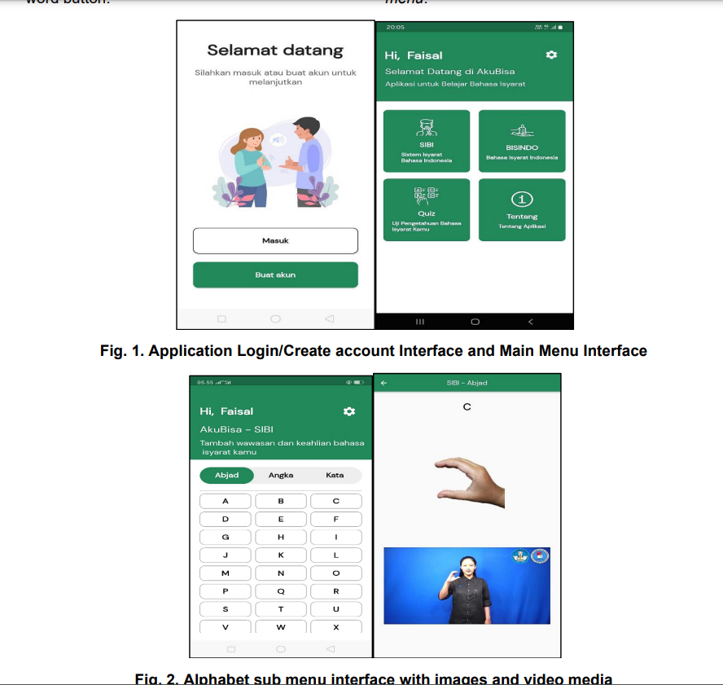

**UX Testing for Mobile Learning Applications of Deaf Children**

<https://d1wqtxts1xzle7.cloudfront.net/84124682/Paper_34-UX_Testing_for_Mobile_Learning_Applications-libre.pdf?1649930842=&response-content-disposition=inline%3B+filename%3DUX_Testing_for_Mobile_Learning_Applicati.pdf&Expires=1726057833&Signature=CnTOSYM2j~GbHIlZJa-CVCm2x3nWUgILqRseaWAG2AvpxC167Qs4S8V7b0aaqMzMvvVfgzXpV~rTcg7q4zJFnOm8z-6I14OyVzivs53rSTEv~XRIrzeqwUm5g8gWkTffAXoaO9nFyJDYdizrt~s-PtUmiW9azSaEPm3IRULc7PzlP4uEA1XsWMFPzZkWCMMAw0Do04p~4MVxyK1DMPDq9iBKMLOh0v~MJ~iOs8W7VWrrgobcLTYwcDfI3xTT2zIURz77z~-XsKswb~UTJ3YGptt3hi2ll07kpxUiwcuoeXSd1Qu4oxFq0XjxjyGLUrWOKPXajM~gu3iB9Ctq4istaQ__&Key-Pair-Id=APKAJLOHF5GGSLRBV4ZA>

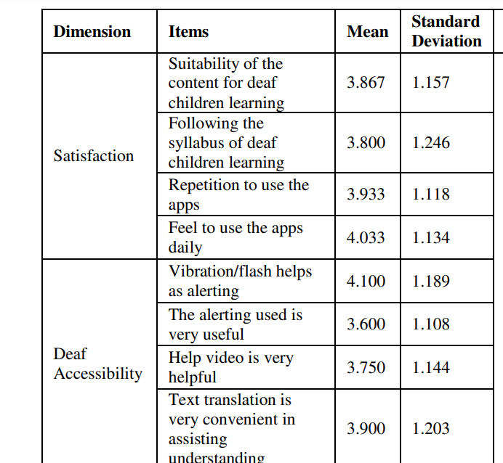

* Use Vibration/flash as alert

**wcag (web content accessibility guidelines)**

Existing:

<https://asl-kids.com/sign-language-app/>

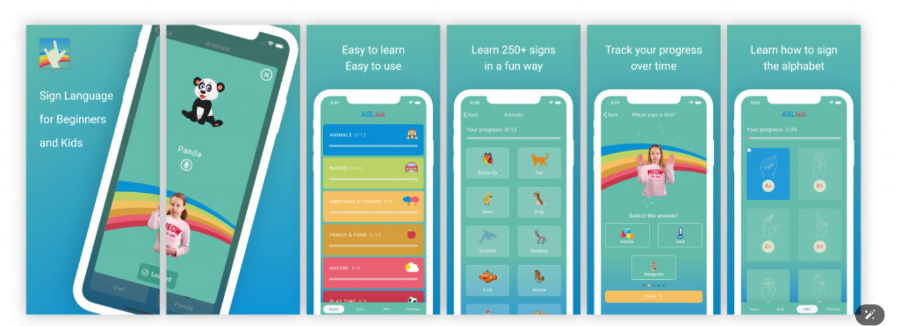

<https://www.signworldlearn.com/>

<https://www.startasl.com/teachers-curriculum/>

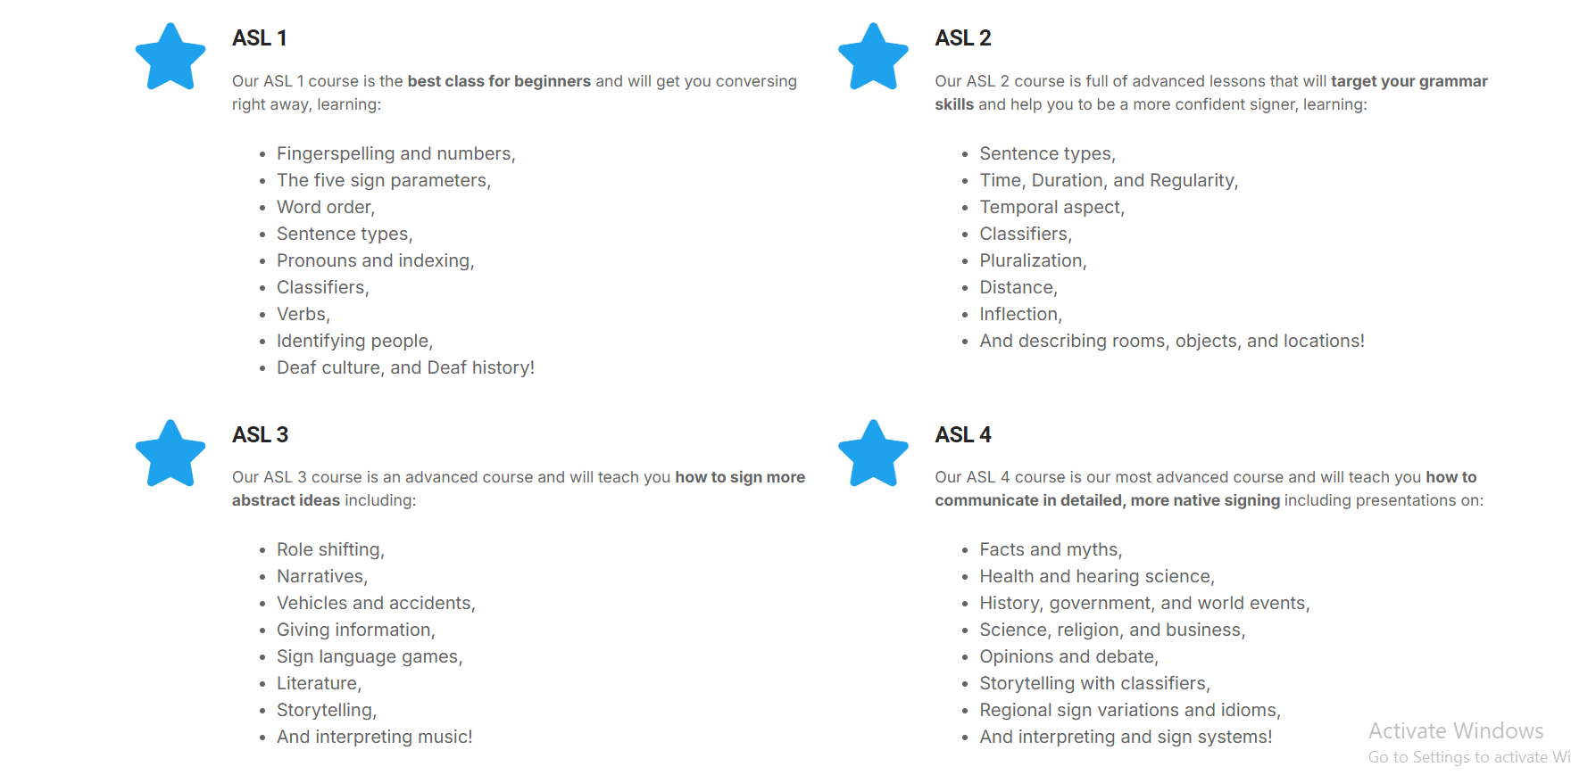

<https://www.facebook.com/media/set/?set=a.289162204501999.8765577.144632412288313&type=3&paipv=0&eav=Afa_1ZcR_Bmlpn_X_wrd-atv4FGefebCRbfyD1o2XST7Vy_cBvoPOOngBcxu67LMb08&_rdr>

**WHAT IS THE WORK ACTUALLY?**

Value Sensitive Design (VSD) and sign language work can be related in several important ways, especially when considering the design and implementation of technologies that facilitate communication for the deaf and hard-of-hearing communities. Here’s how they intersect:

### **1. User-Centered Approach**

* **Understanding Values**: VSD emphasizes the importance of understanding the values and needs of users in the design process. For sign language users, this means recognizing the cultural and social values inherent in sign language and the Deaf community.
* **Inclusion**: Designing technologies that accommodate sign language requires an inclusive approach that respects and values the communication preferences of sign language users.

### **2. Ethical Considerations**

* **Access and Equity**: VSD advocates for ensuring that technologies are accessible to all, including those who use sign language. This involves considering how to make digital platforms, interfaces, and communication tools inclusive.
* **Respect for Culture**: The Deaf community has its own language, culture, and norms. VSD encourages designers to respect these cultural values and avoid imposing dominant language or communication forms that could marginalize sign language.

### **3. Technology Design**

* **Sign Language Recognition**: When designing systems that incorporate sign language recognition (e.g., apps that translate sign language into text or speech), VSD can guide developers to ensure that the technology aligns with the values and communication styles of sign language users.
* **User Feedback**: Engaging with the Deaf community during the design process helps ensure that the technology meets their needs, is intuitive to use, and respects their communication norms.

### **4. Empowerment**

* **Enhancing Communication**: VSD can help create tools that empower sign language users, allowing them to communicate more effectively in various settings, whether in education, healthcare, or social interactions.
* **Advocacy and Representation**: By incorporating VSD principles, designers can help amplify the voices of sign language users, promoting their rights and representation in technology.

### **5. Research and Collaboration**

* **Interdisciplinary Research**: Both VSD and sign language work can benefit from interdisciplinary research that combines insights from design, linguistics, sociology, and technology. This collaboration can lead to innovative solutions that respect and incorporate the values of sign language users.

Human-Computer Interaction (HCI) is closely related to Value Sensitive Design (VSD) and sign language work in several significant ways. Here’s how HCI connects these concepts:

### **1. User-Centered Design**

* **Focus on Users**: HCI emphasizes understanding the needs, preferences, and behaviors of users when designing technology. This aligns with VSD's goal of considering users' values in the design process, particularly for sign language users.
* **Empathy and Engagement**: HCI practices involve engaging with users through methods like interviews, surveys, and usability testing, which can help uncover the specific needs of the Deaf community regarding technology.

### **2. Natural user interface**

### **3. Accessibility and Inclusivity**

* **Designing for All**: HCI frameworks promote inclusive design practices, ensuring that technologies are accessible to a diverse range of users, including those who communicate through sign language. This is crucial for creating equitable access to information and services.

### **4. Simplicity and usability**

### **5. Cultural Considerations**

* **Understanding Cultural Context**: HCI research acknowledges the cultural contexts in which users operate. For the Deaf community, understanding cultural norms and values related to sign language is critical for designing effective and respectful interfaces.
* **Value Reflection**: VSD principles within HCI can help ensure that the design reflects and respects the values of sign language users, including their cultural identity and communication preferences.

[DeepASL: Enabling Ubiquitous and Non-Intrusive Word and Sentence-Level Sign Language Translation](https://www.researchgate.net/publication/323295056_DeepASL_Enabling_Ubiquitous_and_Non-Intrusive_Word_and_Sentence-Level_Sign_Language_Translation)

